Capstone Project Progress

**5th November 2024**

**Group Members**

Saransh Kotha - [sr384758@dal.ca](mailto:sr384758@dal.ca)

Rutvik Vengurlekar – [rt762740@dal.ca](mailto:rt762740@dal.ca)

Rowena Sagaria – [rowenasagaria@dal.ca](mailto:rowenasagaria@dal.ca)

### **Understanding of the Problem**

Initially, we viewed the challenge of finding second-hand goods in Canada as primarily a matter of concern due to our own person experience. However, through our research and survey findings, it has become clear that the issue is much deeper and multifaceted. Many users, particularly international students, and immigrants, face significant barriers due to their unfamiliarity with the marketplace landscape here in Canada.

The survey revealed that **70%** of respondents spend considerable time often over an hour searching for products across multiple platforms. The search does not even finish even after spending hours finding the right product. This not only highlights the inconvenience but also the potential for missed opportunities and frustration. Additionally, the feedback indicated that existing platforms lack sufficient filtering options, which exacerbates the problem.

Moreover, the strong interest in a centralized solution expressed by **90%** of participants underscores the urgency of addressing this need. Users are not just looking for convenience; they seek a reliable, efficient way to navigate the complexities of second-hand shopping. This shift in understanding emphasizes the importance of designing a platform that not only aggregates listings but also enhances user experience through advanced filtering and comparison features. Our solution must cater to the unique challenges faced by newcomers to Canada, making their search for second-hand goods as seamless as possible.

**Project Timeline**

|  |  |  |  |  |  |
| --- | --- | --- | --- | --- | --- |
| **Due Date** | **Task Name** | **Assignee** | **Status** | **Priority** | **Notes** |
| 2024-09-27 | Project Plan Discussion Meeting | Rutvik Vengurlekar | Done | High | Discussion on finding the problem statement |
| 2024-10-03 | Project Proposal | Rutvik Vengurlekar | Done | Medium |  |
| 2024-10-10 | Customer Validation and Interview | Rowena Sagaria | Done | High |  |
| 2024-10-17 | Gather insights on user preferences | Rutvik Vengurlekar | Done | Medium | Filter options, alert systems, and UI expectations |
| 2024-10-17 | Google Survey | Rowena Sagaria | At risk | Medium |  |
| 2024-10-24 | Market analysis | Saransh Kotha | On track | Low | Analyze existing platforms like Facebook Marketplace and Kijiji |
| 2024-10-24 | Create wireframes | Rowena Sagaria | At risk | High | Major sections: Home, Search Results, Product Page, Alerts, Login Page, etc. |
| 2024-11-07 | Project progress report | Rutvik Vengurlekar | On track | High |  |
| 2024-11-07 | Project progress presentation | Rowena Sagaria | On track | Medium |  |
| 2024-11-07 | Wireframe and Web Development | Saransh Kotha | On track | High |  |
| 2024-11-18 | First Prototype | Saransh Kotha | At risk | Medium |  |
| 2024-11-21 | Review and iterate on prototypes | Rowena Sagaria | To do | High |  |
| 2024-11-24 | Conduct usability tests | Rutvik Vengurlekar | To do | High |  |
| 2024-11-28 | Final Project Presentation | Saransh Kotha | To Do | Medium |  |
| 2024-11-28 | Project Report | Rutvik Vengurlekar | On track | Medium |  |

**User Survey on Buying Second-Hand and Used Products Online — Validation Summary**

We surveyed international students, migrants, and immigrants in Canada to validate our proposed solution of a central platform for second-hand goods. The survey was conducted to gauge their shopping habits, preferences, and struggles while hunting for used products on multiple platforms.

**Key Findings**

**User Status and Experience**:

* Among those who used second-hand marketplaces, 60% were either new immigrants or new citizens.
* 40% had never gone to any second-hand product websites, this means our platform access a potential market segment.

**Interest Towards Second Hand Products:**

* Of those who had searched for second-hand products, eight in ten were looking for electronics, furniture, and cars. Such general interest implies a mega-market for our platform.

**Time Spent Searching:**

* More than 70% of the respondents said it took them anywhere from 30 minutes to more than an hour to look for products. This emphasizes a usual annoyance concerning the current fragmented way of doing things, where users must go through several platforms searching for what they want.

**Use of Filters:**

* Three quarters of participants said that they filter when searching for products, but 65% said that current platforms lack adequate filtering. The above feedback indicated the need for a more advanced filter in our solution to improve the user experience

**Price Comparison:**

* While the survey found that 85% of respondents compare prices between platforms, the experience is a laborious one. That makes our app – which will automatically compare prices and make shopping smoother – even more valuable.

**A Centralised Solution — The Interest**

* Nine in 10 of our participants expressed that they would find an app that collates listings from multiple sites and has comparison capabilities or very appealing. Results showed many respondents felt using such a tool would save them considerable time and better streamline their shopping experience.

**Feature Recommendations:**

* Search participants provided options that would help them to better receive the alerts, but many would benefit from tailored alerts captured by item-wise alerts (70%), geographical alerts (65%) and filter options (80%). We will directly use these insights in our design and development process.

**Implications for Design**

The results of the survey give us extremely valuable information that will help shape the development of our platform. We need to gather detailed and in-depth knowledge about our target audience to use them wisely for our features. In other words, advanced filtering and price comparison functionalities are going to be a priority in our design. Furthermore, we will be able to translate these insights from frustration (regarding existing platforms) into minimising and translating these to a more intuitive interface and user experience.

Which really gives the assurance that our platform addresses these essential and validated needs, helping make it simple for people to find second-hand goods and make the overall experience more enjoyable. This validation period has shown that a single solution is desired in the market and proves the relevance and applicability of our project.

**Current Progress**

Currently we complete the first part of the design process. We have made the Login page, Registration page and the first welcome page from where the User/Customer can search for the product they are looking to purchase.

The Welcome Page provides a clean and intuitive interface with a prominent search bar where users can directly enter the type of product they are interested in, enhancing the ease of navigation for our visitors. The next phase of our development process will focus more on creating individual product landing pages of diverse types of products searched and implementing advanced filter options. These filters will allow users to sort products by categories such as price, location, brand, and condition and will give them control to find exactly what they need. The filter functionality will be very crucial in enhancing the user experience, making it simple for customers to narrow down their choices efficiently, especially when dealing with a wide range of product listings aggregated from various platforms like Facebook, Kijiji etc.

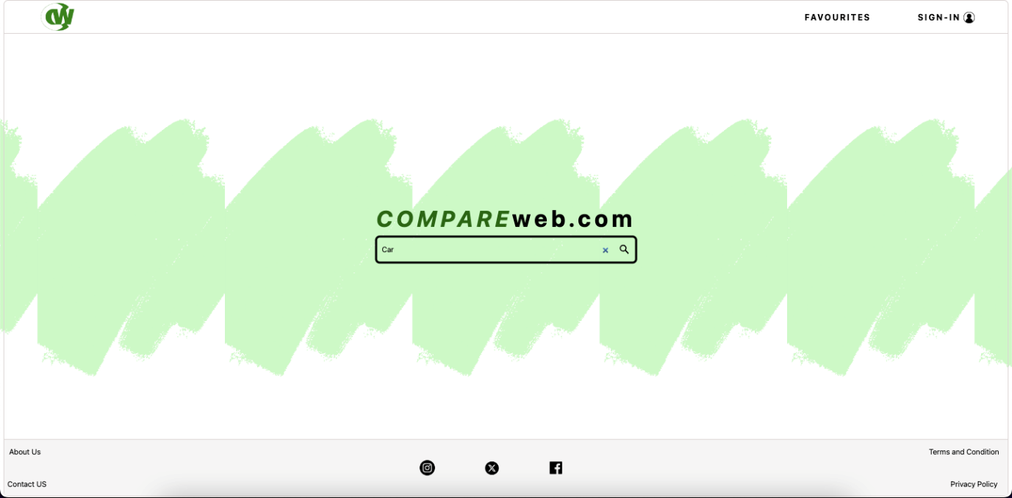

Figure : Landing Page to Search products

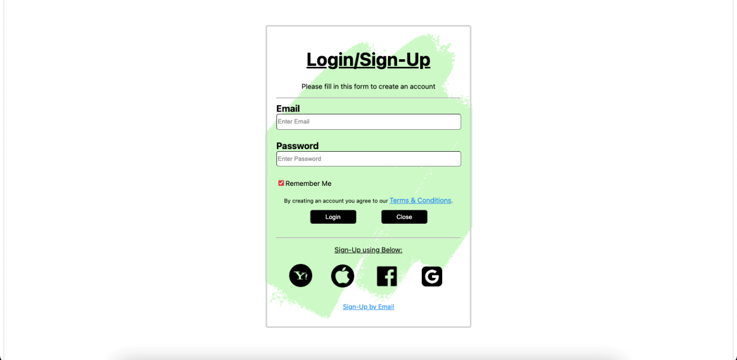

Figure : Login and Registration Page